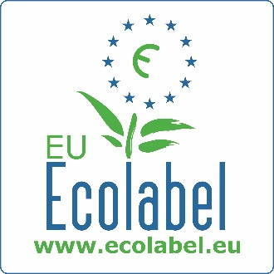

PROPOSAL FOR INCLUSION OF A NEW PRODUCT GROUP IN THE
EU ECOLABEL SCHEME

Please complete this form and send it to the EU Ecolabel Helpdesk: helpdesk-eu-ecolabel@adelphi.de

Date:
Contact information
Company or organisation (if applicable):
Activity sector:
Address:

Contact person
Name:
Position:
Email:
Telephone number:
Fax (optional):

- Product group designation:

  - How would you define this new product group (in terms of name, products covered, sub-product groups, etc.)?

  - Is the product (group) targeting consumers or businesses?

- Reasoning for choice and scope of the product group:

  - What are the advantages and limitations of the product(s) compared to competing products and/or other products produced by the same company (if applicable)?

- Significant potential for effecting environmental improvements:

  - Please provide information on environmental impacts of the product group (preferably using life cycle assessment data/studies). Please indicate critical and controversial issues related to these claims on environmental impact if any.

  - Please provide information on potential environmental benefits that the establishment of the EU Ecolabel product group may bring.

- Market description:

  - How is this product’s market segmented? Please provide information on the corresponding market shares.

  - Please provide intra-community market data for the sector, including volumes, turnover and main actors.

  - Could you describe any possible trade issues (for instance, in terms of access to the market, intellectual property, etc.)?

  - What is the current and future potential for market penetration of the product(s) bearing the EU Ecolabel? Please provide relevant market estimates.

- The environmental awareness:

  - Has this product(s) already been awarded a certification or ecolabel under another scheme?

- Complementary information

  - Are you/your organisation interested in initiating and participating in the development of EU Ecolabel criteria for the proposed product group? If yes, please describe how you propose to do so.

  - Please suggest stakeholders who should be involved in criteria development.

- Other information you would like to add to complete this form:

- References of data and information collected and used to fill out this form:

Thank you for your interest in the development of the EU Ecolabel.
This information will be kept and considered within the EU Ecolabel product group prioritisation process.
For more information on product group development, please see Annex I of the new Regulation on the EU Ecolabel available here.

More information about the EU Ecolabel is available here: www.ecolabel.eu.

